**4.REACTJS-HQL**

**FOLDER STRUCTURE**

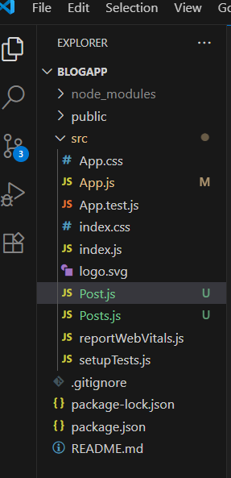

**Post.js**

import React from 'react';

class Post extends React.Component {

  render() {

    const { title, body } = this.props;

    return (

      <div style={{ border: '1px solid gray', padding: '10px', margin: '10px 0' }}>

        <h2>{title}</h2>

        <p>{body}</p>

      </div>

    );

  }

}

export default Post;

**Posts.js**

import React from 'react';

import Post from './Post';

class Posts extends React.Component {

  constructor(props) {

    super(props);

    this.state = {

      posts: [],

      error: null

    };

  }

loadPosts = () => {

    fetch('https://jsonplaceholder.typicode.com/posts')

      .then(response => response.json())

      .then(data => this.setState({ posts: data }))

      .catch(error => this.setState({ error }));

  }

  componentDidMount() {

    this.loadPosts();

  }

componentDidCatch(error, info) {

    alert("An error occurred: " + error);

  }

render() {

    const { posts } = this.state;

return (

      <div>

        <h1>All Posts</h1>

        {posts.map(post => (

          <Post key={post.id} title={post.title} body={post.body} />

        ))}

      </div>

    );

  }

}

export default Posts;

App.js

import React from 'react';

import './App.css';

import Posts from './Posts';

function App() {

  return (

    <div className="App">

      <Posts />

    </div>

  );

}export default App;

**OUTPUT**

